CAMP SUSQUEHANNA BENEFIT TRAP SHOOT
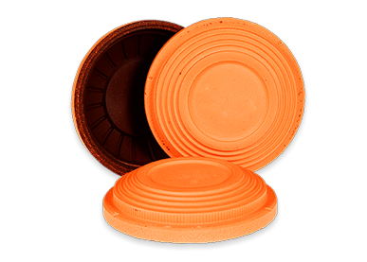
Saturday, March 18th
Northside Sportsmen’s Association

50 Bird Handicap Event
All shooters will shoot from 22 Yard Line
Registration starts at 9:00AM
Shooting starts at 10:00AM

$50 per shooter includes targets and food/drink
Ammo available for purchase

Targets……..………………………………………..…..…….$50
Lucky Number Option…....................................$10
Lewis…………………………………………………..…………$10

CASH PRIZES for Champion ($250), Runner-Up ($75) and 3rd Place ($50)

Lucky Number Option
Two lucky numbers will be drawn and all shooters whose scores ending in either of those two numbers that played the option will be eligible for the shoot off. Charity will receive 50% of the option money.
Shoot-off winner for each lucky number drawn will receive 25% of the option money.

Lewis Class
Lewis will be 2 Class Minimum Divided 60% - 40%

*Ties on all money will divide*
**Shoot management reserves the right to modify or alter program if conditions warrant**

ALL PROCCEEDS BENEFIT PEDIATRIC BURN SURVIVORS AT CAMP SUSQUEHANNA!

DONATIONS ARE GREATLY APPRECIATED!

SPONSORSHIPS AVAILABLE – EMAIL US FOR A SPONSOR FORM
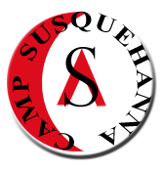
Any questions please contact Emily Noftz at shotgunsports@northsidesportsmen.com

